Kenneth Lopez 08/22/2022

MySQL Exercises Project 1 [Creating Tables and Sakila DB Exercises]

1. Write a SQL statement to create a simple table countries including columns country_id,country_name and region_id:

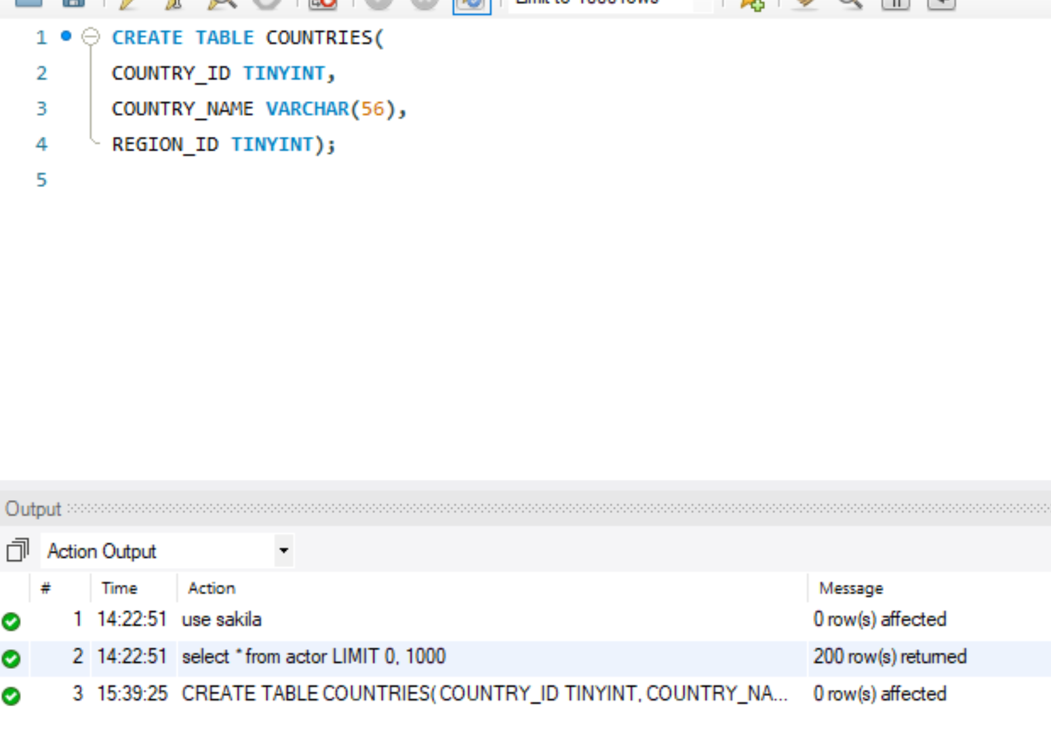

1. Write a SQL statement to create a simple table countries including columns country_id,country_name and region_id which is already exists.Verify it as well:

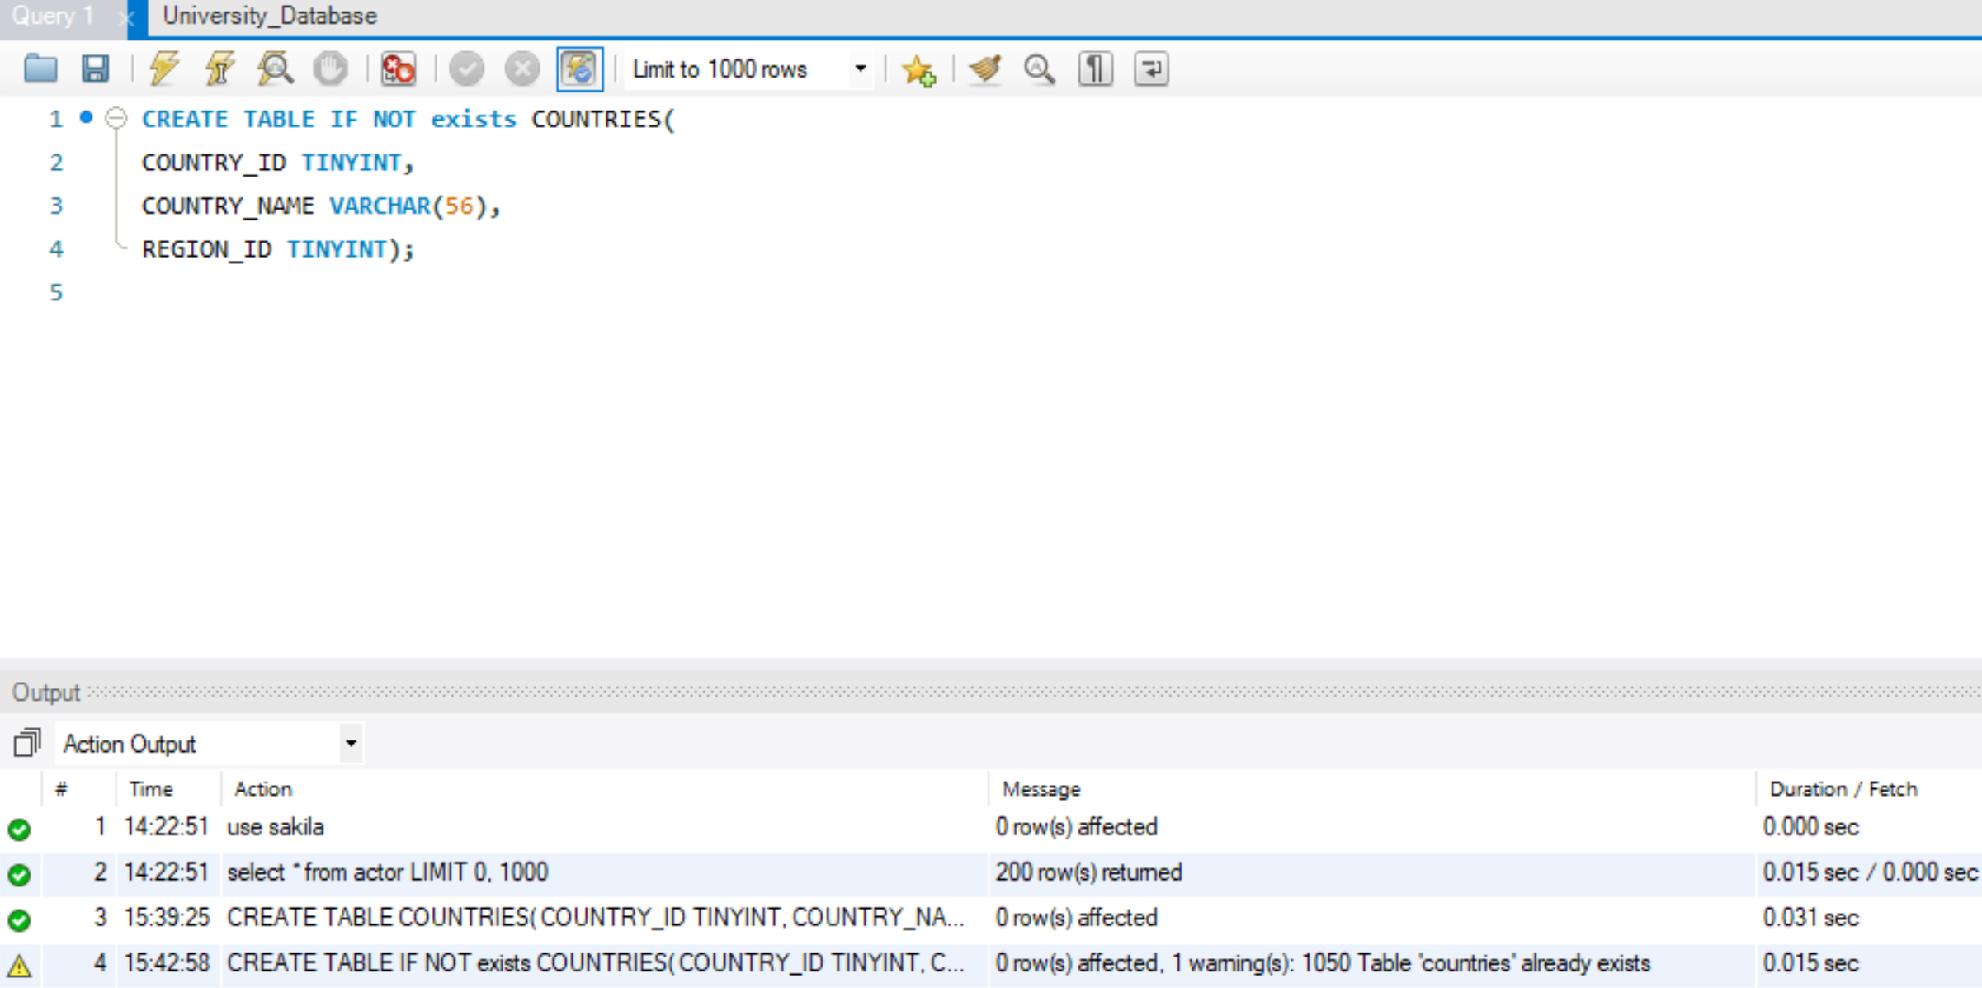

1. Write a SQL statement to create the structure of a table dup_countries similar to countries:

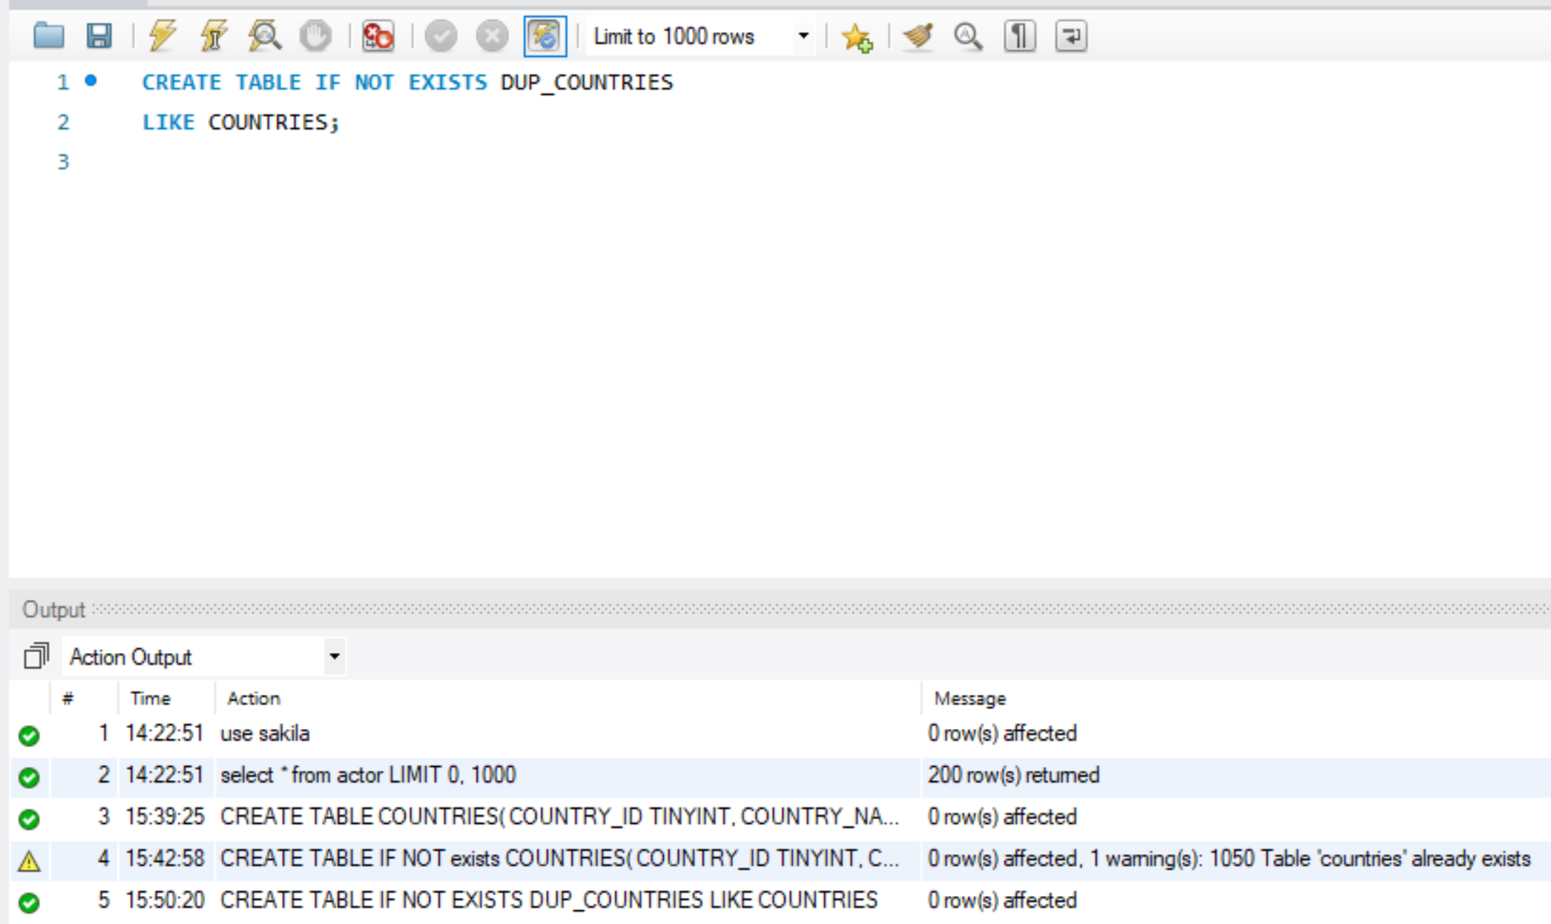

1. Write a SQL statement to create a duplicate copy of countries table including structure and data by name dup_countries:

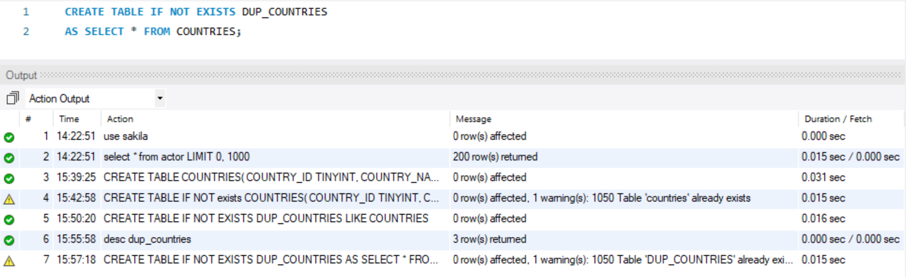

1. Write a SQL statement to create a table countries set a constraint NULL:

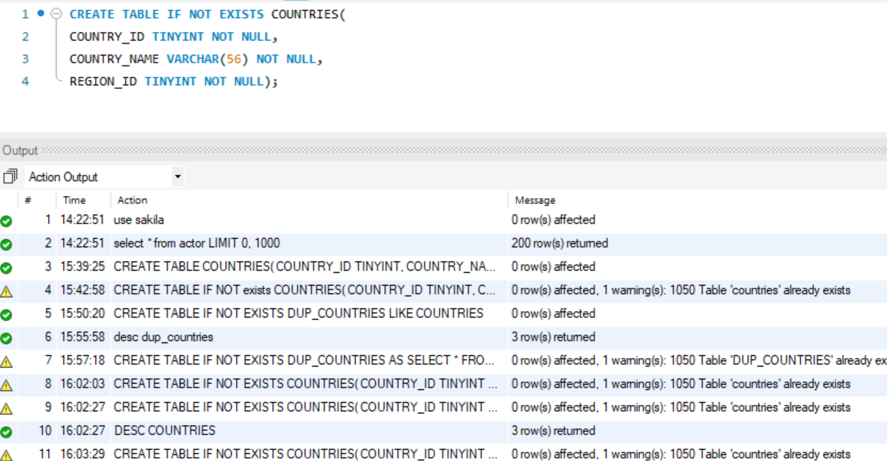

1. . Write a SQL statement to create a table named jobs including columns job_id, job_title, min_salary, max_salary and check whether the max_salary amount exceeding the upper limit 25000:

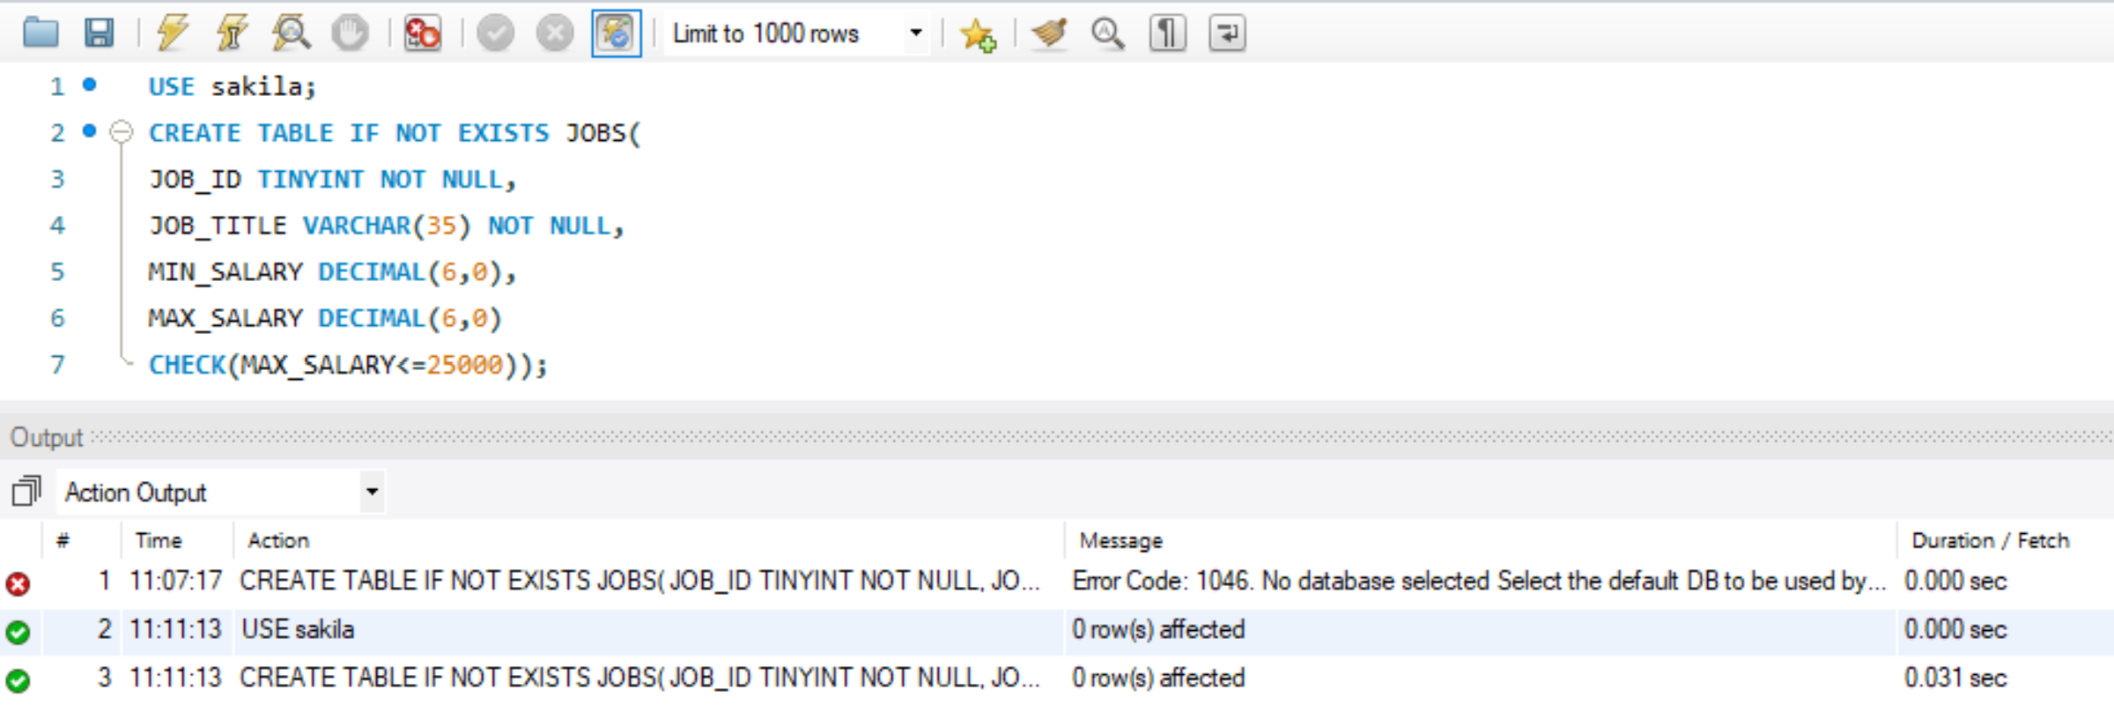

1. Write a SQL statement to create a table named countries including columns country_id, country_name and region_id and make sure that no countries except Italy, India and China will be entered in the table:

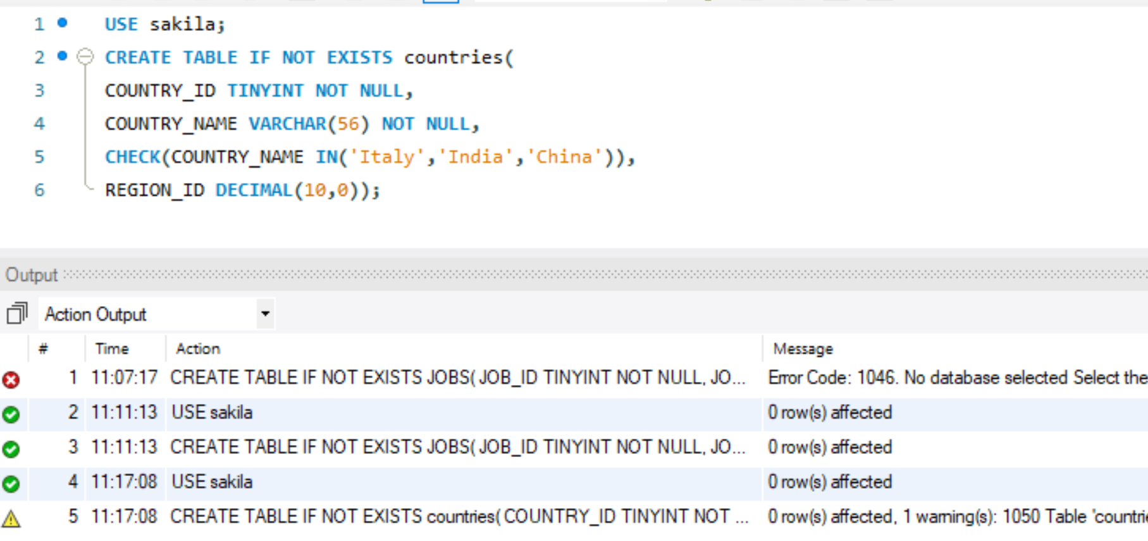

1. Write a SQL statement to create a table named job_histry including columns employee_id, start_date, end_date, job_id and department_id and make sure that the value against column end_date will be entered at the time of insertion to the format like '--/--/----':

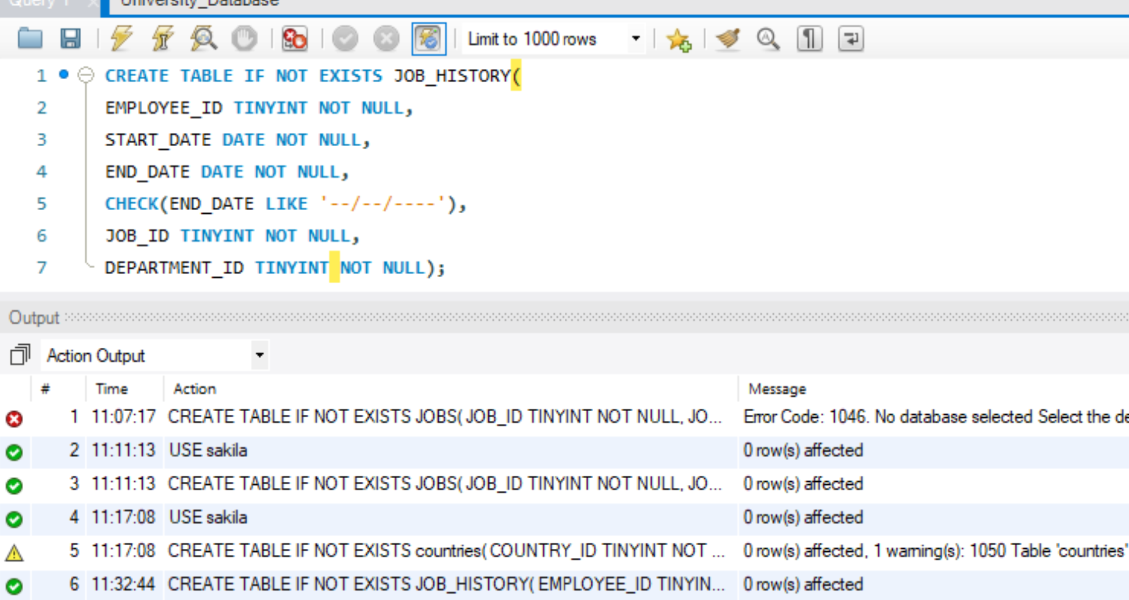

1. Write a SQL statement to create a table named countries including columns country_id,country_name and region_id and make sure that no duplicate data against column country_id will be allowed at the time of insertion:

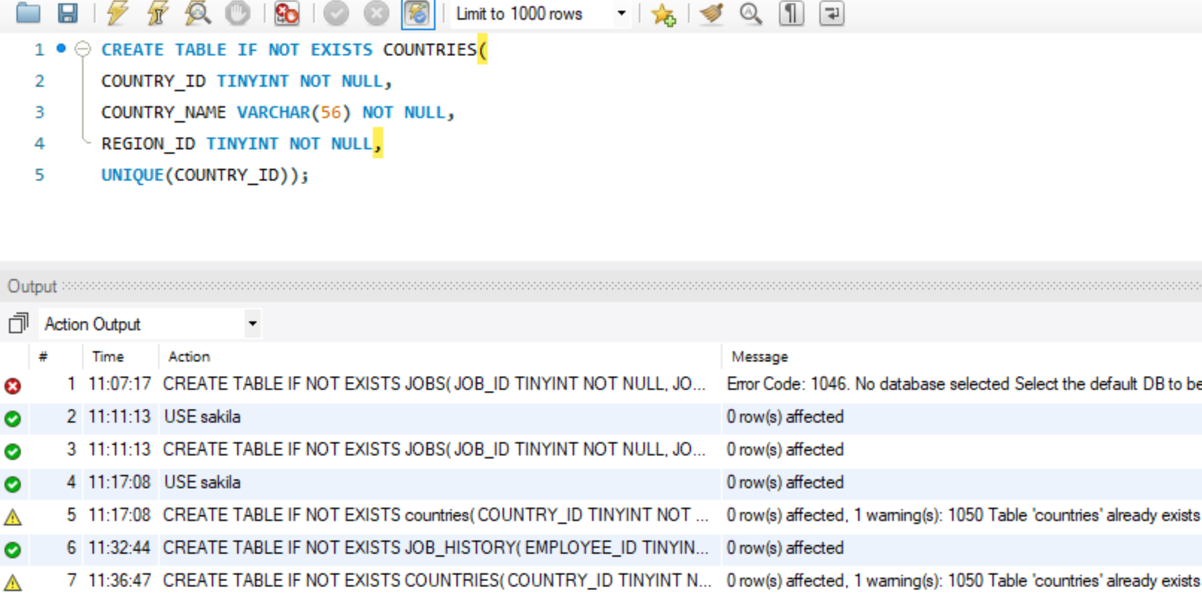

1. Write a SQL statement to create a table named jobs including columns job_id, job_title, min_salary and max_salary, and make sure that, the default value for job_title is blank and min_salary is 8000 and max_salary is NULL will be entered automatically at the time of insertion if no value assigned for the specified columns:

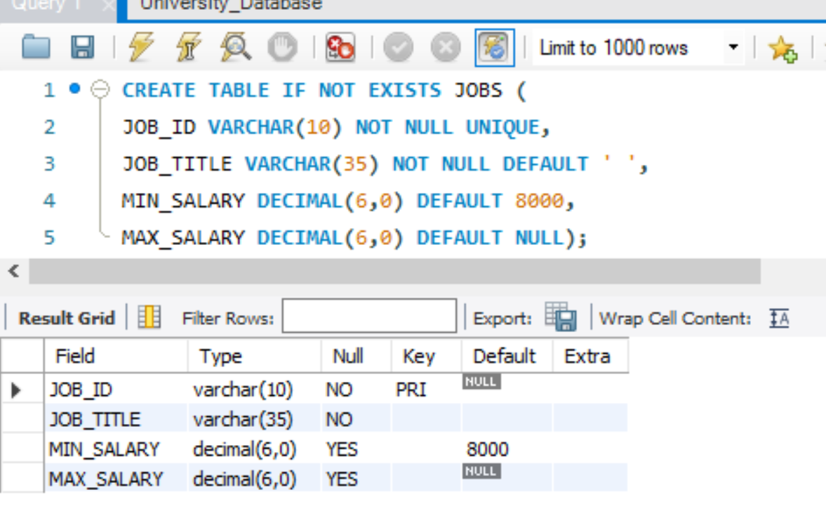

1. Write a SQL statement to create a table named countries including columns country_id, country_name and region_id and make sure that the country_id column will be a key field which will not contain any duplicate data at the time of insertion:

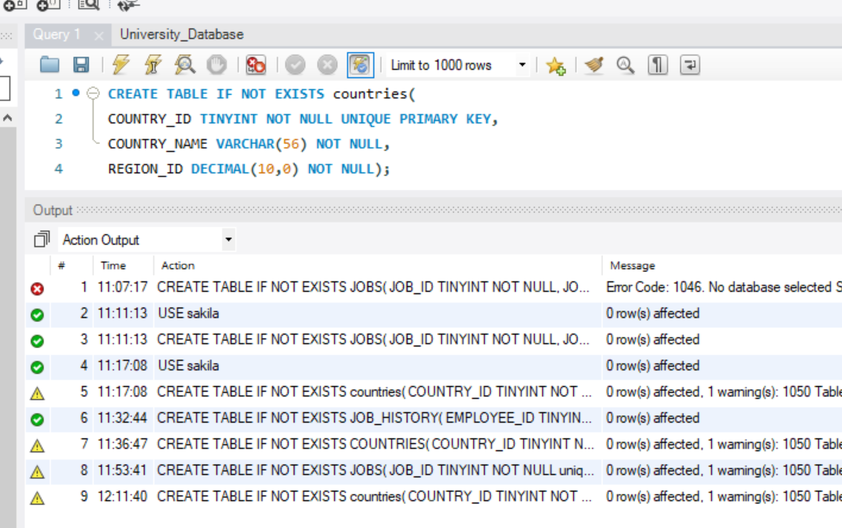

1. Write a SQL statement to create a table countries including columns country_id, country_name and region_id and make sure that the column country_id will be unique and store an auto incremented value:

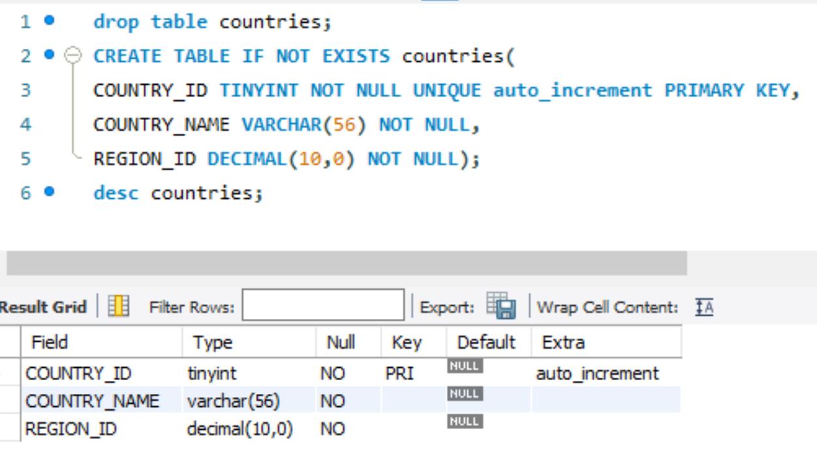

1. Write a SQL statement to create a table countries including columns country_id, country_name and region_id and make sure that the combination of columns country_id and region_id will be unique:

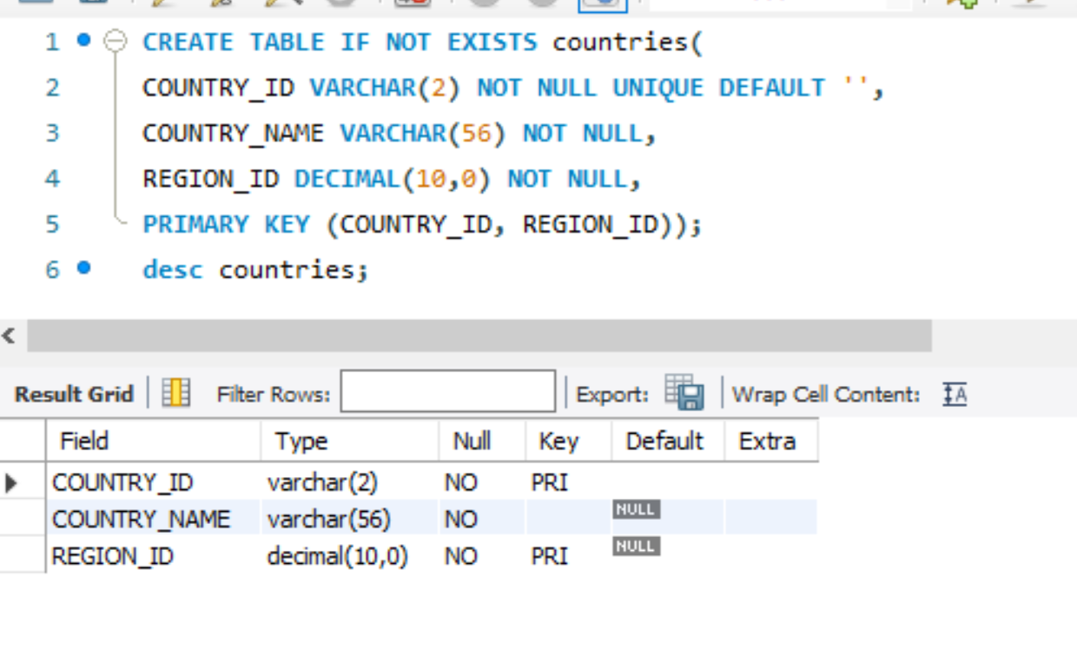

1. Write a SQL statement to create a table job_history including columns employee_id, start_date, end_date, job_id and department_id and make sure that, the employee_id column does not contain any duplicate value at the time of insertion and the foreign key column job_id contain only those values which are exists in the jobs table:

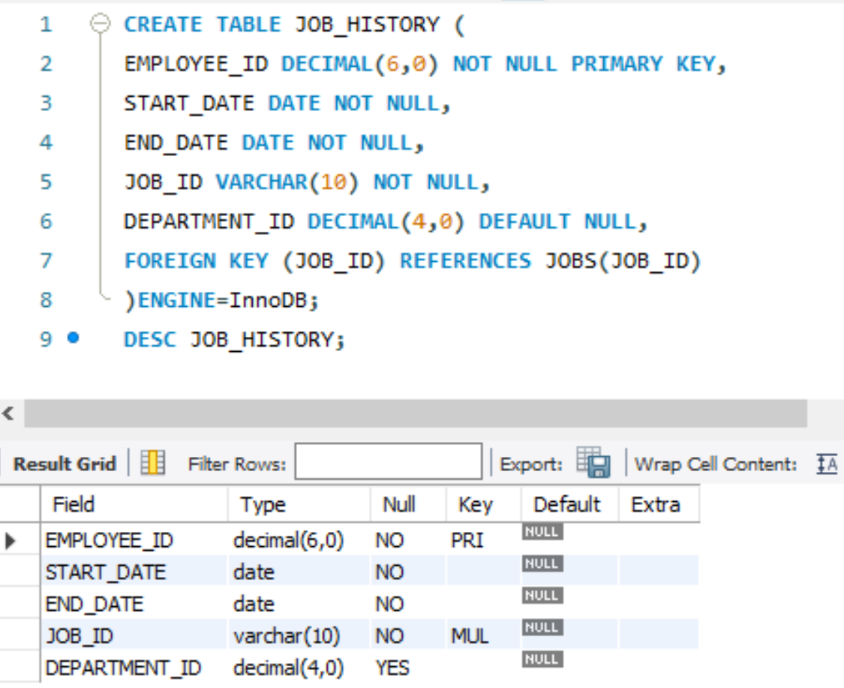

1. Write a SQL statement to create a table employees including columns employee_id, first_name, last_name, email, phone_number hire_date, job_id, salary, commission, manager_id and department_id and make sure that, the employee_id column does not contain any duplicate value at the time of insertion and the foreign key columns combined by department_id and manager_id columns contain only those unique combination values, which combinations are exists in the departments table:

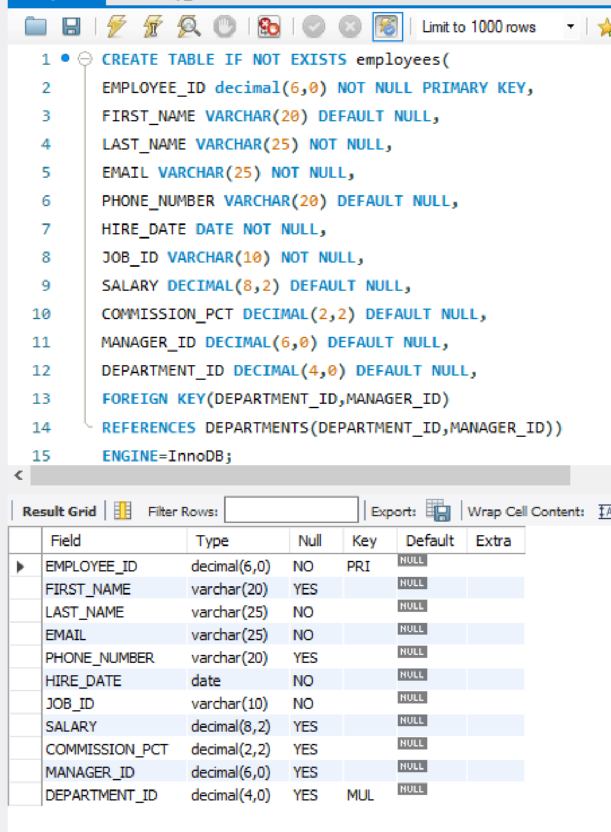

1. Write a SQL statement to create a table employees including columns employee_id, first_name, last_name, email, phone_number hire_date, job_id, salary, commission, manager_id and department_id and make sure that, the employee_id column does not contain any duplicate value at the time of insertion, and the foreign key column department_id, reference by the column department_id of departments table, can contain only those values which are exists in the departments table and another foreign key column job_id, referenced by the column job_id of jobs table, can contain only those values which are exists in the jobs table. The InnoDB Engine have been used to create the tables.

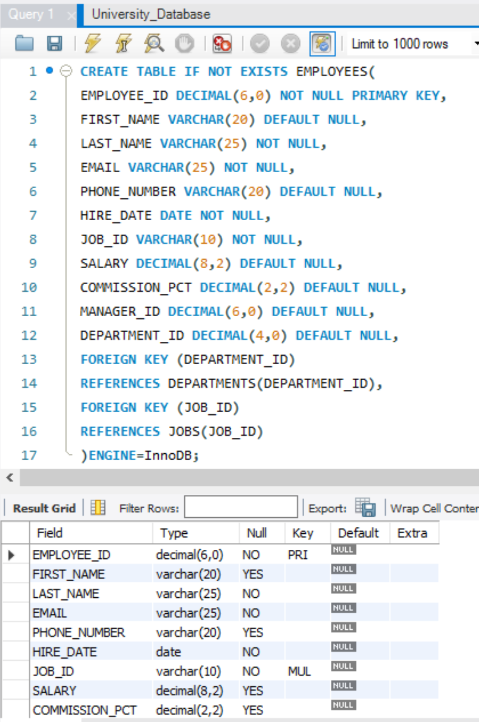

1. Write a SQL statement to create a table employees including columns employee_id, first_name, last_name, job_id, salary and make sure that, the employee_id column does not contain any duplicate value at the time of insertion, and the foreign key column job_id, referenced by the column job_id of jobs table, can contain only those values which are exists in the jobs table. The InnoDB Engine have been used to create the tables. The specialty of the statement is that, The ON UPDATE CASCADE action allows you to perform cross-table update and ON DELETE RESTRICT action reject the deletion. The default action is ON DELETE RESTRICT.

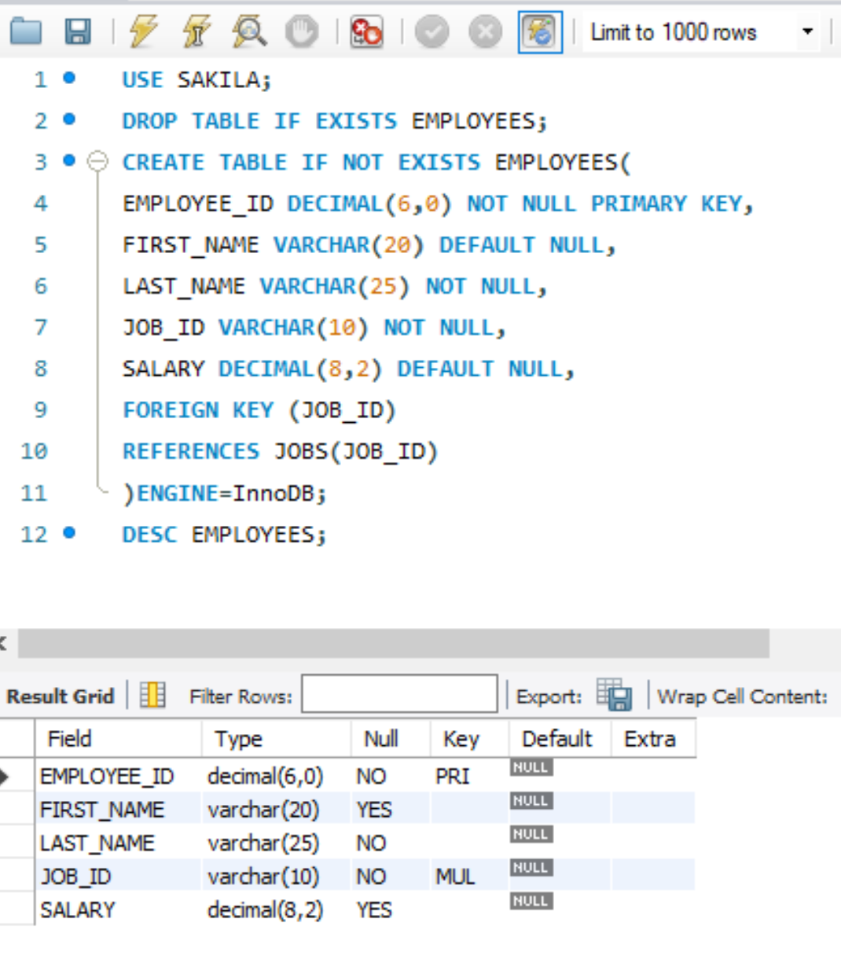

1. Write a SQL statement to create a table employees including columns employee_id, first_name, last_name, job_id, salary and make sure that, the employee_id column does not contain any duplicate value at the time of insertion, and the foreign key column job_id, referenced by the column job_id of jobs table, can contain only those values which are exists in the jobs table. The InnoDB Engine have been used to create the tables. The specialty of the statement is that, The ON DELETE CASCADE that lets you allow to delete records in the employees(child) table that refer to a record in the jobs(parent) table when the record in the parent table is deleted and the ON UPDATE RESTRICT actions reject any updates:

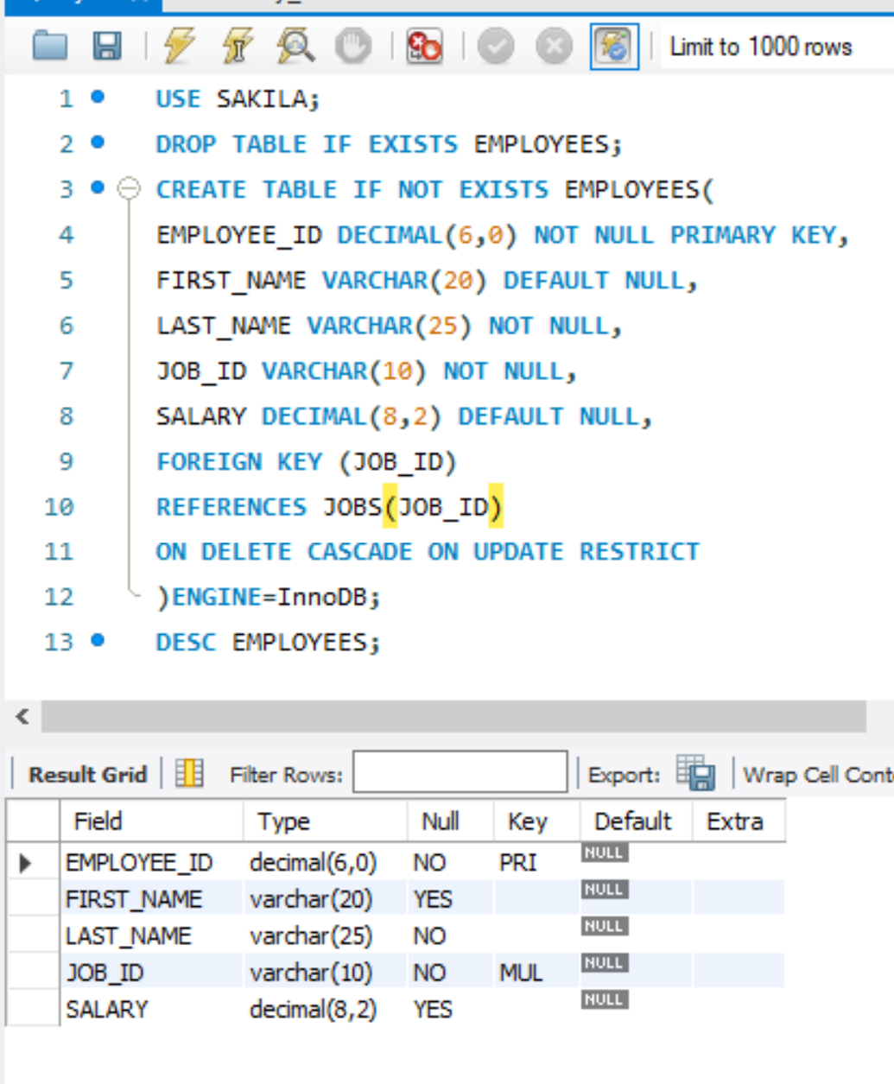

1. Write a SQL statement to create a table employees including columns employee_id, first_name, last_name, job_id, salary and make sure that, the employee_id column does not contain any duplicate value at the time of insertion, and the foreign key column job_id, referenced by the column job_id of jobs table, can contain only those values which are exists in the jobs table. The InnoDB Engine have been used to create the tables. The specialty of the statement is that, The ON DELETE SET NULL action will set the foreign key column values in the child table(employees) to NULL when the record in the parent table(jobs) is deleted, with a condition that the foreign key column in the child table must accept NULL values and the ON UPDATE SET NULL action resets the values in the rows in the child table(employees) to NULL values when the rows in the parent table(jobs) are updated:

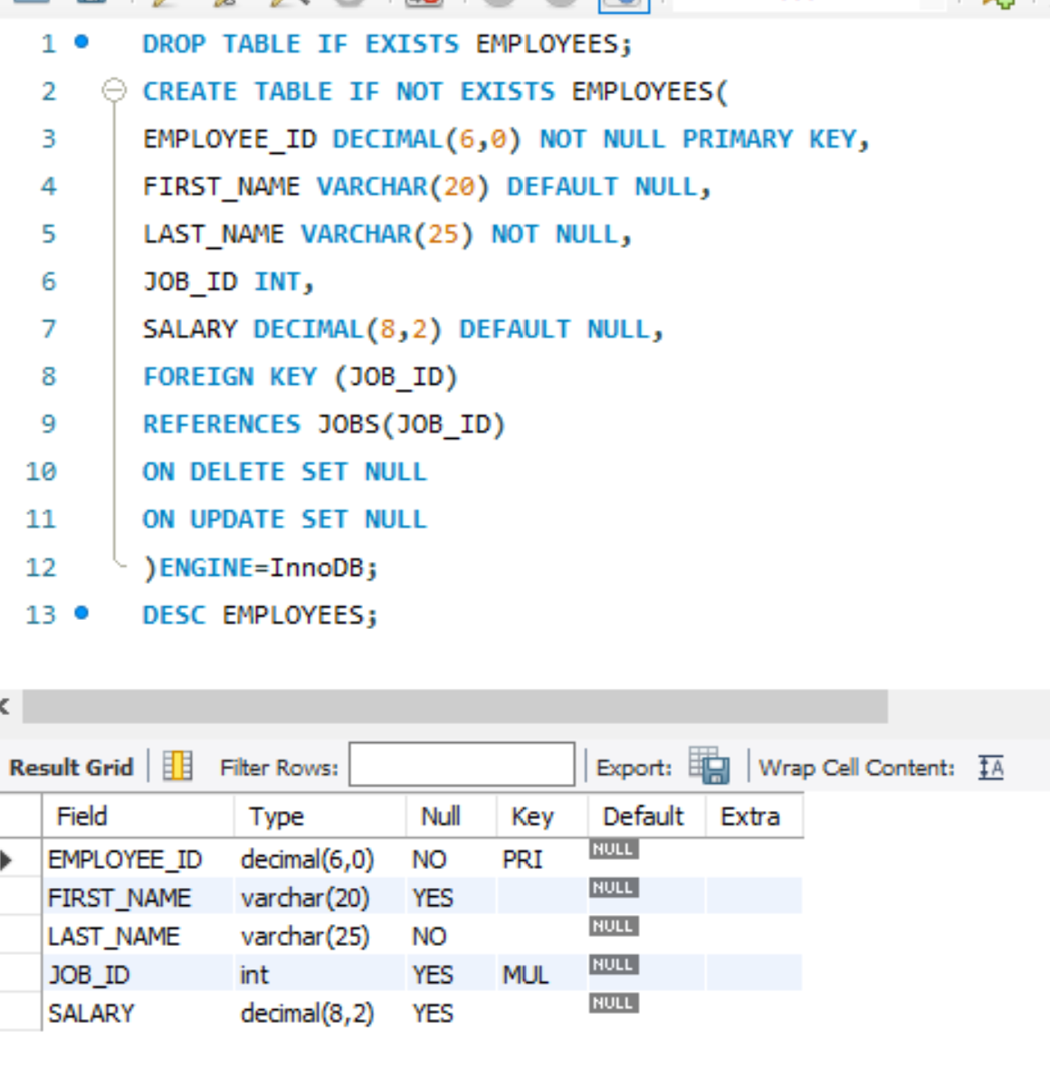

1. Write a SQL statement to create a table employees including columns employee_id, first_name, last_name, job_id, salary and make sure that, the employee_id column does not contain any duplicate value at the time of insertion, and the foreign key column job_id, referenced by the column job_id of jobs table, can contain only those values which are exists in the jobs table. The InnoDB Engine have been used to create the tables. The specialty of the statement is that, The ON DELETE NO ACTION and the ON UPDATE NO ACTION actions will reject the deletion and any updates:

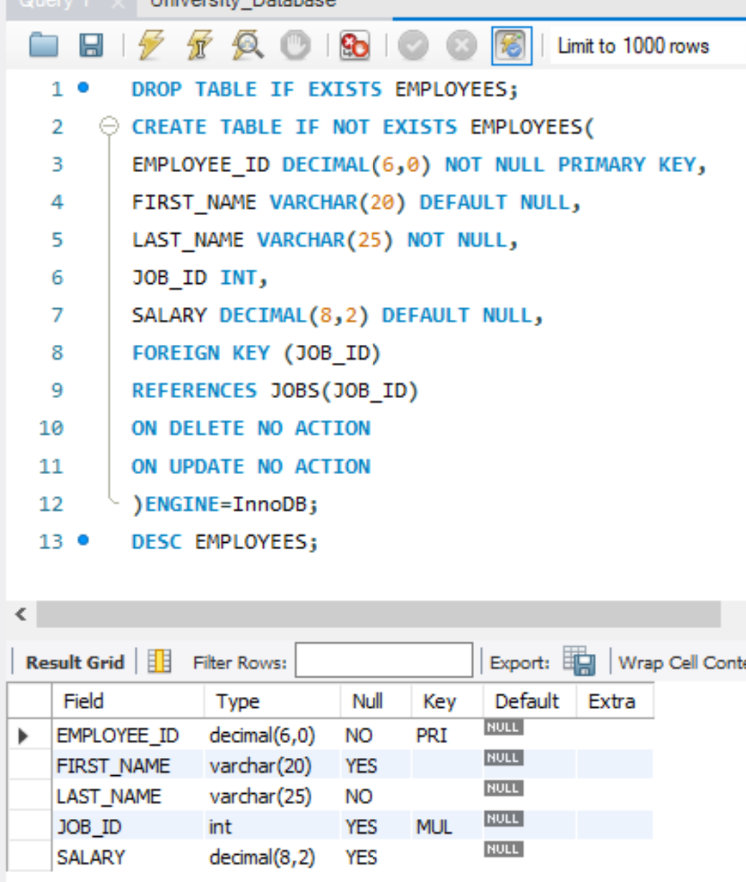

1. Sakila DB exercises

* 1. Which actors have the first name ‘scarlett’

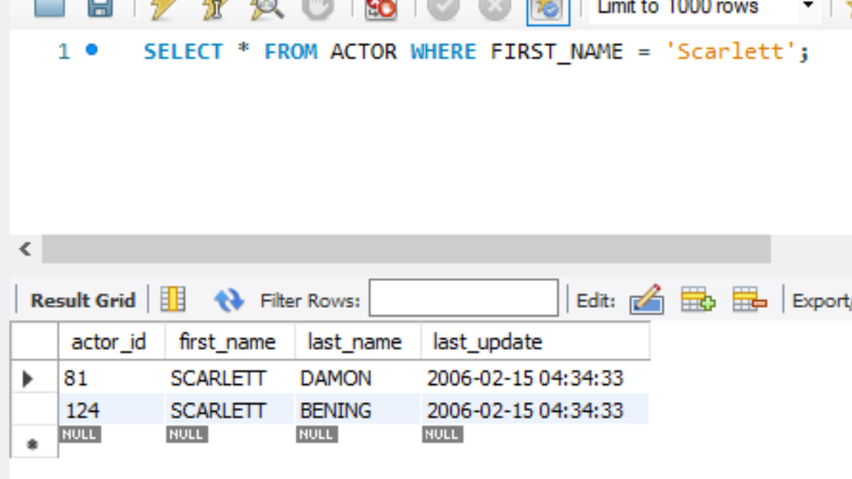

* 2. Which actors have the last name ‘johansson’

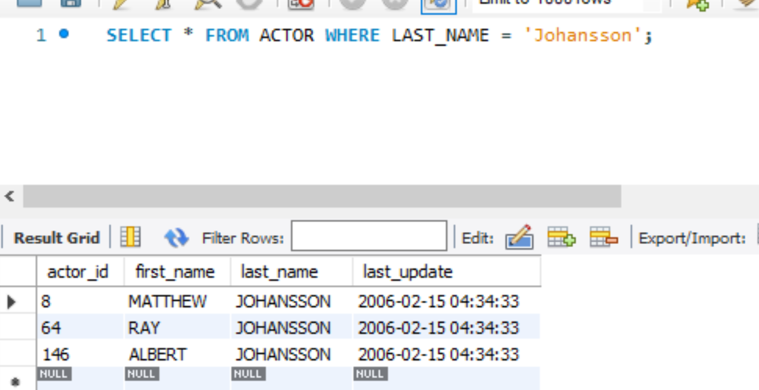

* 3. How many distinct actors last names are there?

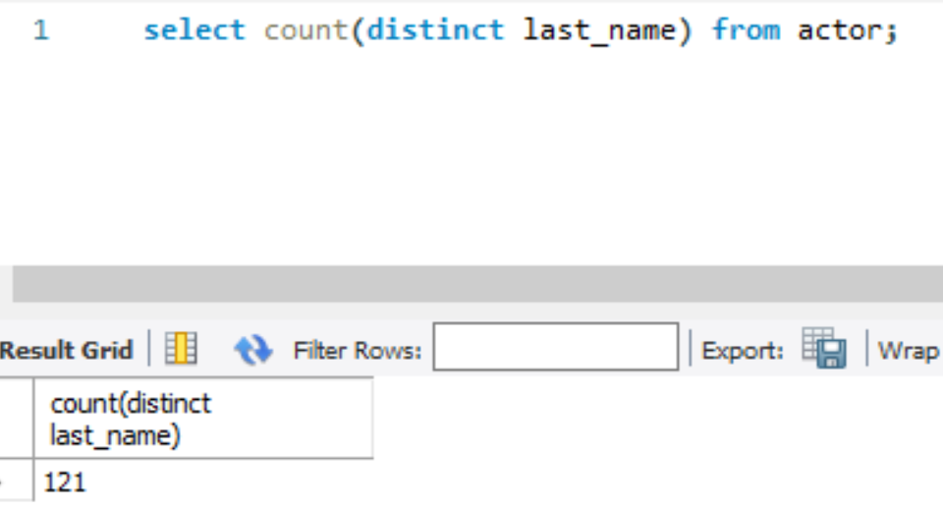

* 4. Which last names are not repeated?

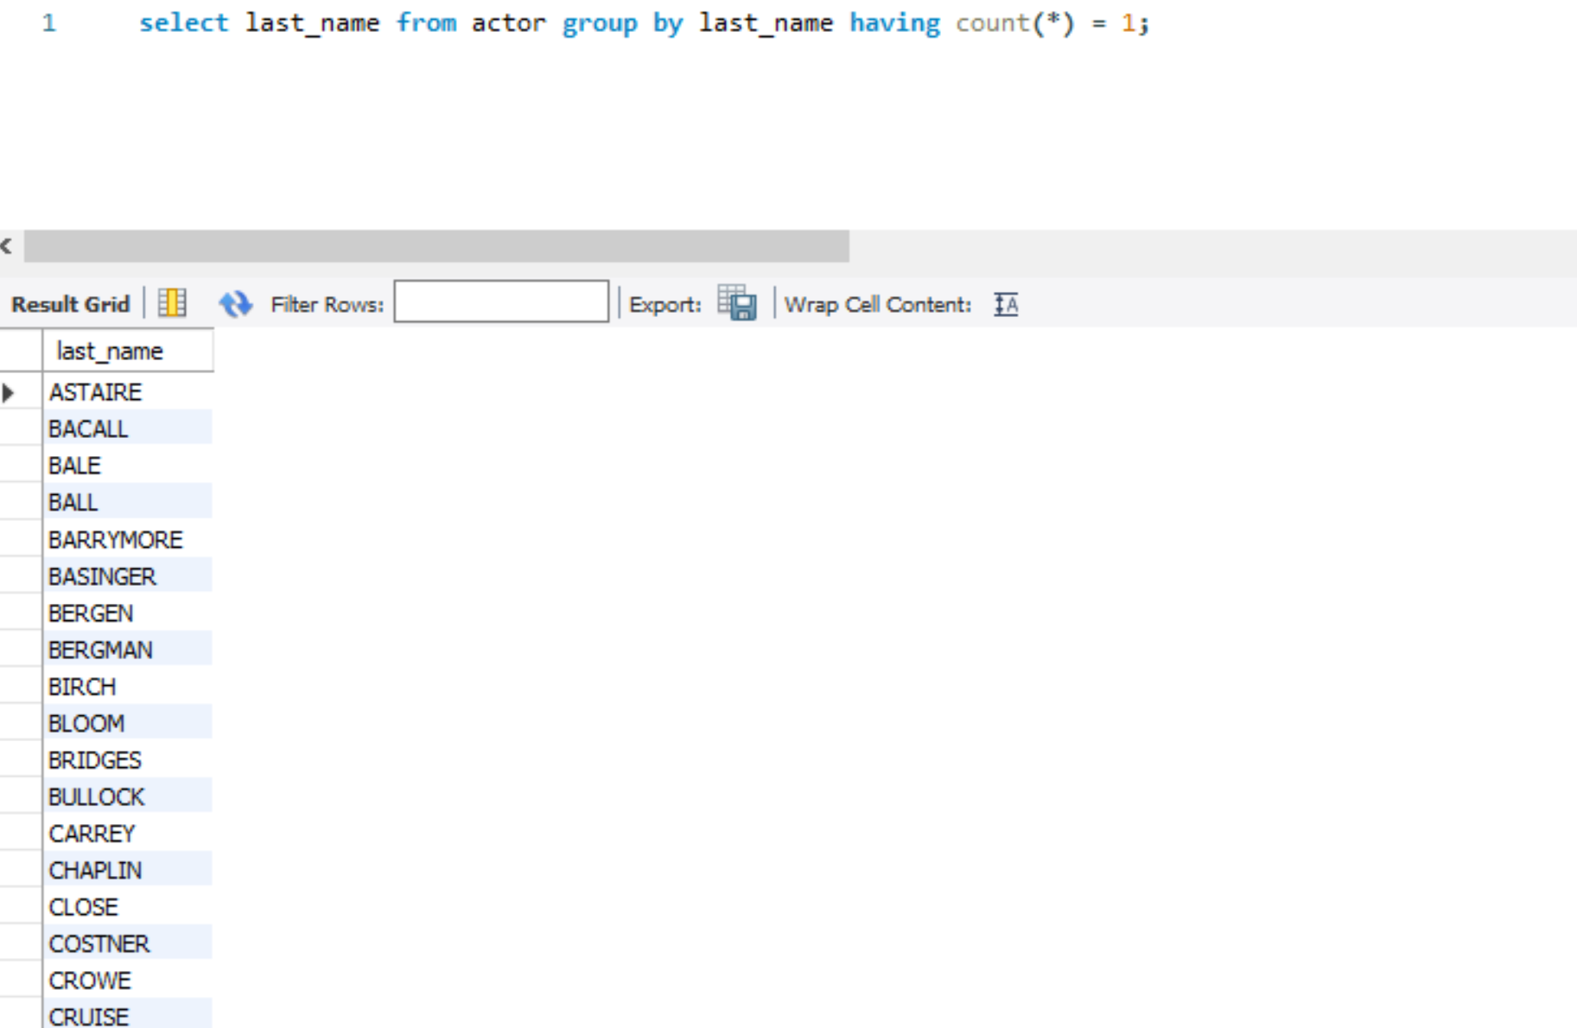

* 5. Which last names appear more than once?

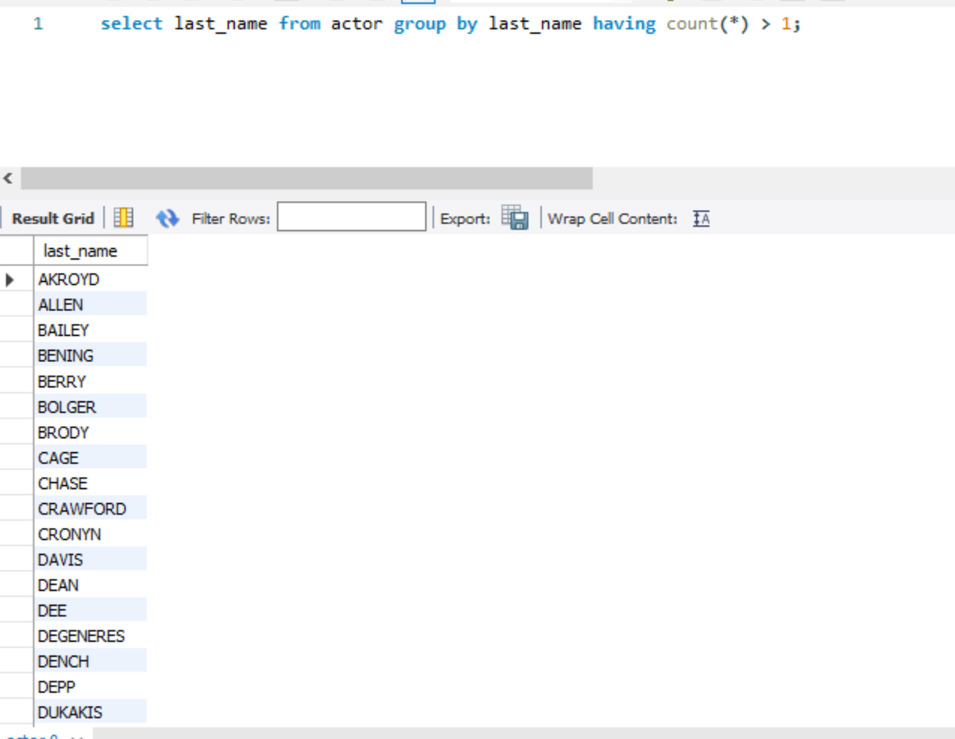

* 6. Which actor has appeared in the most films?

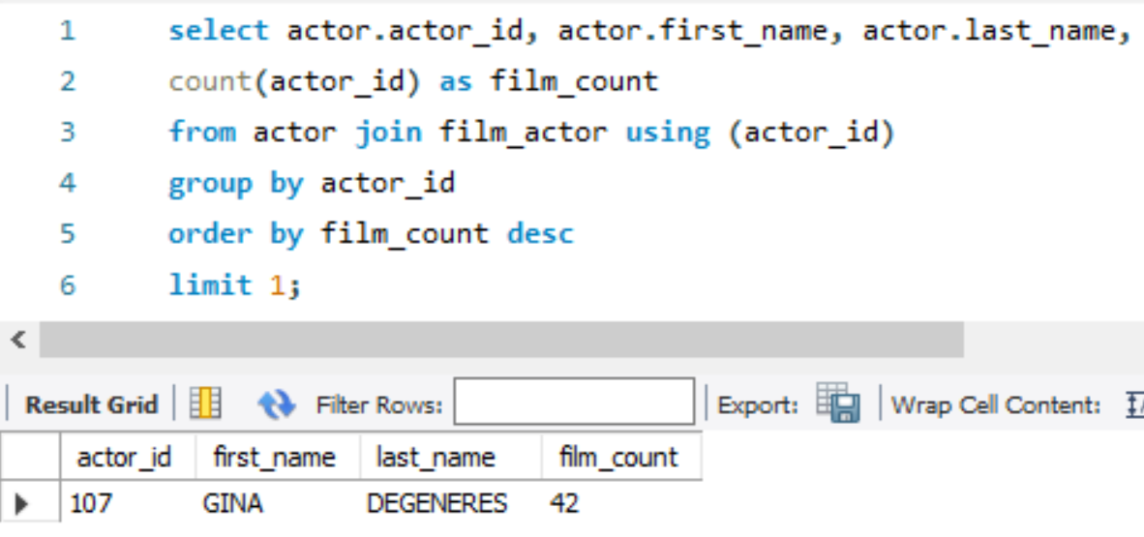

* 7. Is ‘academy dinosaur’ available for rent from store 1?

Step 1: To see if it exists:

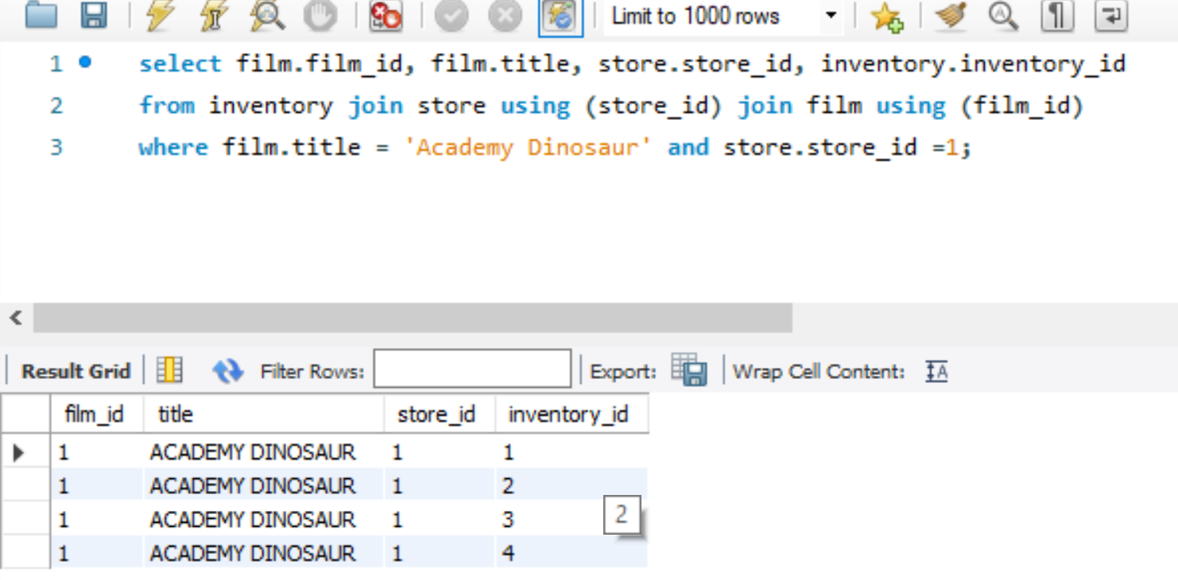

Step 2: To view the data:

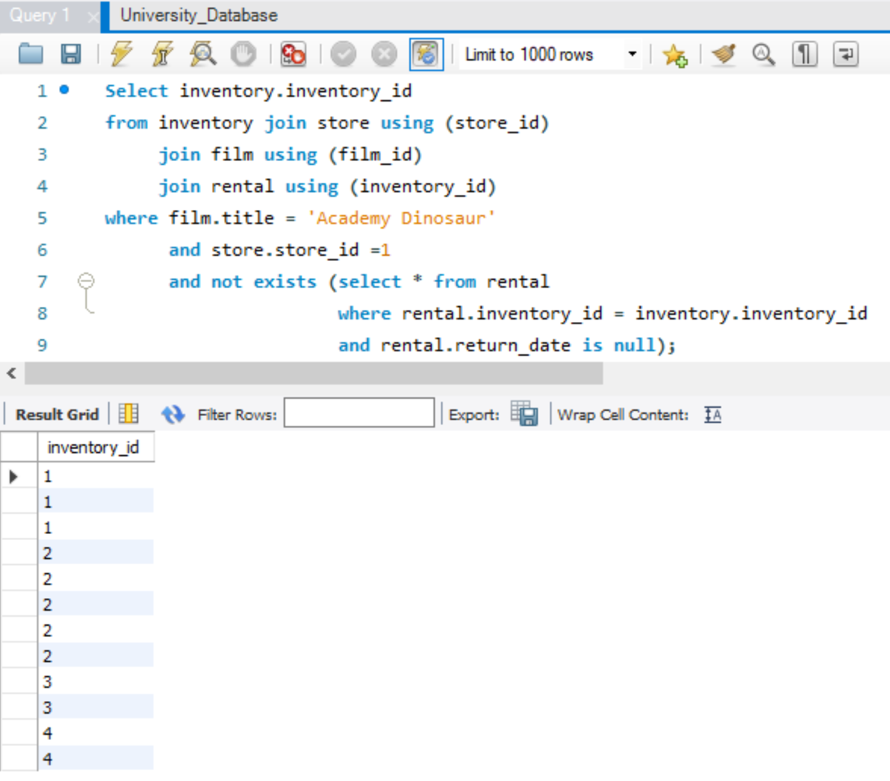

* 8. Insert a record to represent mary smith renting ‘academy dinosaur’ from mike hillyer at store 1 today .



* 9. When is ‘academy dinosaur’ due?

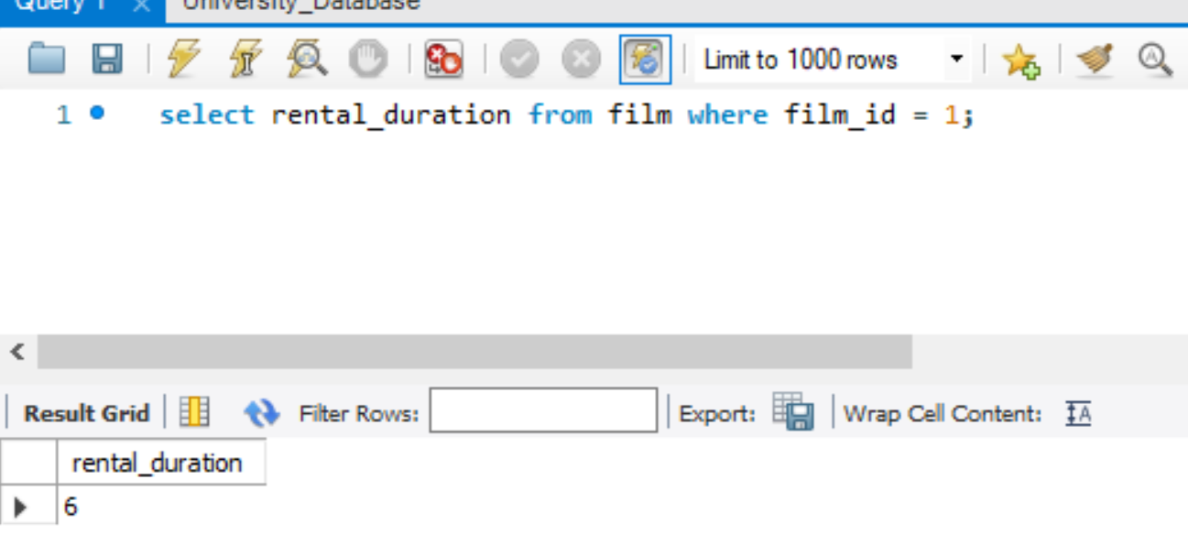

* 10. What is that average running time of all the films in the sakila db?

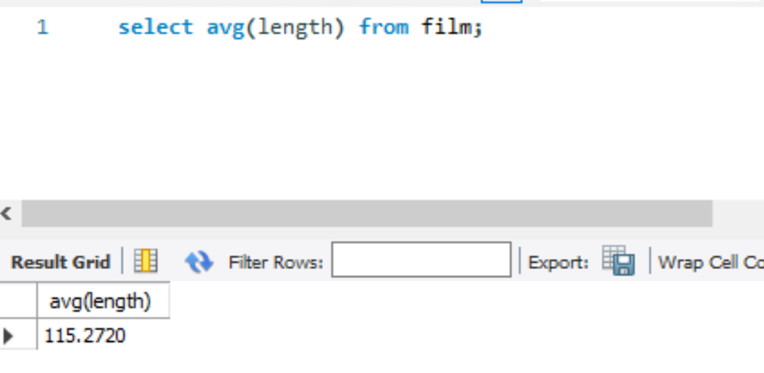

* 11. What is the average running time of films by category?

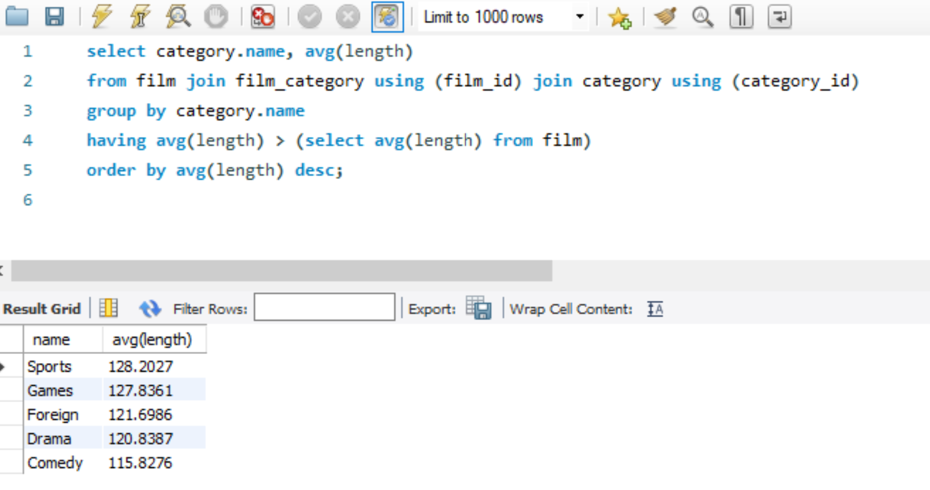

* 12. Why does this query return the empty set?
* a. Select * from film natural join inventory;

Although table film and table inventory has the same field names (film_id and last_update), a prerequisite for data to show is that both tables must have the same values. As a result, the table is empty.